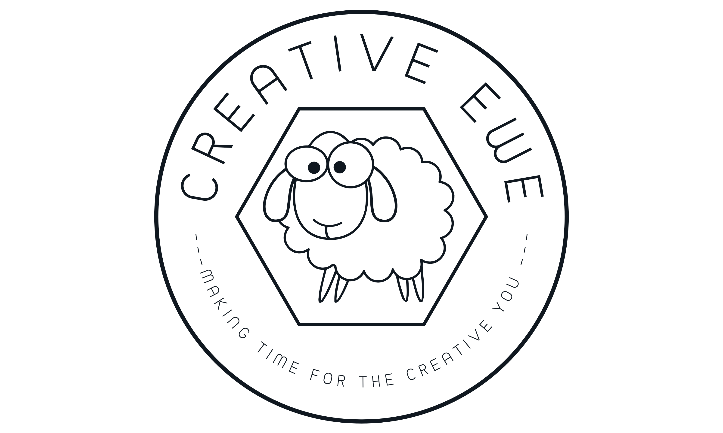

Botanical Casting Workshop Risk Assessment www.creativeewe.co.uk
Botanical Casting – Using natural clay as a base and a range of flowers, leaves, grasses and other foliage to make negative imprints into it. Plaster is then poured into the mould, left to dry and the result is a beautiful positive relief cast. The workshops can also include a session foraging in the local area. Maximum 20 participants
Category of Hazard | Impact of Hazard | Who could be Harmed? | Control Measures
Slips, trips and falls  These could occur within the venue or while outside foraging.  Creative Ewe are not responsible for participants activities prior to the start of the session or after its conclusion. | Trauma from impact of falling which could lead to bruising, abrasions, cuts, fractures of bone, concussion | Participants and Instructors | Prior to session area is inspected to assess for risk.  In the event of a spill, liquid to be cleaned up and wet floor signs to be displayed while it dries  Any areas of uneven flooring will be communicated to all participants and cordoned off if necessary.  Participants are informed to wear suitable footwear for sessions that include woodland foraging  All points of exit will be kept clear of obstructions.  All participants belongings such as coats and handbags should be stored away in a designated area and not left on the floor or under tables.  The venues we use are accessibility friendly and can accommodate mobility needs. There are accessible toilets and hand rails for steps. Our venues do not require participants to use stairs.
Foreign Objects in Eye  This could occur during the session. Organic, clay and plaster materials being used | Irritation to eye, obscured vision, allergic reaction, pain | Participants and Instructors | Safety glasses are provided for participants to wear to avoid contact with their eyes.  Instructions include the safe handling of plaster powder to limit its spread in the air when being mixed and poured.  Care to be taken when handling dried botanicals to reduce the risk of parts breaking off  First Aid box includes an eye washing kits should it be required.
Ingestion of Materials  This could occur during the session. Organic material, plaster and clay being used. | Irritation to the mouth, throat and respiratory tract.  Choking or vomiting | Participants and Instructors | Face masks are provided for participants to wear when working with the plaster powder and mix.  None of the foliage provided in the session presents a toxic risk.  Handbasin and individual towels are provided for handwashing prior to breaks where food may be consumed.
Skin Irritation or Reaction  This could occur while within the venue or when out foraging. | Inflammation of the skin including swelling and hives.  Could trigger an anaphylaxis reaction | Participants and Instructors | Nitrile gloves are provided for participants to wear throughout the duration of the workshop.  Clean water is available to rinse skin should an irritation occur.  Instructions to handle foliage carefully to avoid scratches to the skin.
Minor cuts, scratches or abrasions to the skin.  This could occur while in the venue or when out foraging  Creative Ewe are not responsible for participants activities prior to the start of the session or after its conclusion. | Bleeding from minor wounds | Participants and Instructors | Instructions on the correct use of equipment including using scissors to cut foliage and sizing adjustable mould rings.  First Aid box contains sterile water and a variety of wound dressings.  Antibacterial gel is available.
Foreign object in skin  This could occur as a result of handling botanical materials | Splinters, pain and tenderness | Participants and Instructors | Care is taken during preparations to either remove thorns and spikes from the foliage or to separate them out so that participants are aware prior to handling them.  Tweezers are available to remove small splinters if necessary
Postural Issues  The sessions are between 4 and 5 hours longs. Participants are able to move around freely and sit down. | Aches and pains | Participants and Instructors | Participants are given their own designated workspace on a table. There is enough space for them to comfortably move around and complete the required tasks. They have a chair to sit on should they chose to do so, although some tasks can be completed from a standing position.  There is a minimum of 30 minutes lunch break where participants are free to leave the venue should they wish to do so.

Completed by: Hannah Gregory – Director, Creative Ewe – theflock@creativeewe.co.uk
Date: 1st September 2024
Review: 31st August 2025

